C++类的继承与派生(10003809171j)
班级:信2007-2 学号:20203907 姓名:周朝勇
一 实验目的
- 使学生理解派生类中的成员与基类成员的关系；
- 使学生掌握派生类构造函数的定义和继承成员的初始化方法；
- 使学生掌握各类成员的访问控制特性及其使用方法；
- 培养学生结合实际问题建立合理的类层次结构的能力；
二 实验环境
- 所需硬件环境为微机；
- 所需软件环境为Microsoft Visual C++ 6.0或Code::Blocks ；
三 实验内容
（一）、以点类Point为基类设计圆类Circle【CPP0013】
【源代码】
此处附上完整的程序源代码，要求包括Point类、Circle类和main()，要有必要的注释，不能是图片形式。
#include <iostream>
using namespace std;
class Point{
protected:
double x;
double y;
public:
Point(double xv=0,double yv=0);//有参构造
Point(const Point &p); //拷贝构造
~Point(); //析构函数
void show() const; //显示Point信息
double area()const; //面积=0
void setX(double xv); //设置X坐标
void setY(double yv); //设置Y坐标
double getX() const; //获取X坐标
double getY() const; //获取Y坐标
};
//有参构造
Point::Point(double xv,double yv){
x=xv;
y=yv;
cout<<"Point Constructor run"<<endl;
}
//拷贝构造
Point::Point(const Point &p){
x=p.x;
y=p.y;
cout<<"Point CopyConstructor run"<<endl;
}
//析构函数
Point::~Point(){
cout<<"Point Destructor run"<<endl;
}
//显示Point
void Point::show() const{
cout<<"("<<x<<","<<y<<")";
}
//设置X坐标
void Point::setX(double xv){
x=xv;
}
//设置Y坐标
void Point::setY(double yv){
y=yv;
}
//面积函数
double Point::area() const{
return 0;
}
//获取X坐标
double Point::getX() const{
return x;
}
//获取Y坐标
double Point::getY() const{
return y;
}

const double PI = 3.14159;

class Circle:public Point{
private:
//double x;
//double y;
double radius;
public:
Circle(double x = 0,double y = 0,double r = 0):Point(x,y){
//this->x = xx;
//this->y = yy;
this->radius = r;
cout<<"Circle Constructor run"<<endl;
}
Circle(Circle &r):Point(r){
x = r.x;
y = r.y;
radius = r.radius;
cout<<"Circle CopyConstructor run"<<endl;
}
~Circle(){
cout<<"Circle Destructor run"<<endl;
}
void setRadius(double r); //返回和设置radius
double getRadius() const;
double circumference() const; //计算圆的周长
double area() const; //计算圆的面积
void show() const; //显示圆的信息，显示格式为：(圆心X坐标,圆心Y坐标),Radius=半径
};

//返回和设置radius
void Circle::setRadius(double r){
radius = r;
}
double Circle::getRadius() const{
return radius;
}

//计算圆的周长
double Circle::circumference() const{
return 2*PI*radius;
}

//计算圆的面积
double Circle::area() const{
return PI*radius*radius;
}

//显示圆的信息，显示格式为：(圆心X坐标,圆心Y坐标),Radius=半径
void Circle::show() const{
cout<<"("<<x<<","<<y<<"),Radius="<<radius;
}

int main(void){
double r;
cin>>r;
Circle c1(1,2,4),c2,c3(c1);
c1.show();
cout<<endl<<"Area="<<c1.area()<<endl<<"Circumference="<<c1.circumference()<<endl;
c2.show();
cout<<endl<<"Area="<<c2.area()<<endl<<"Circumference="<<c2.circumference()<<endl;
c3.setRadius(r);
c3.show();
cout<<endl<<"Area="<<c3.area()<<endl<<"Circumference="<<c3.circumference()<<endl;
return 0;
}
【运行测试】
此处附上程序运行的测试截图
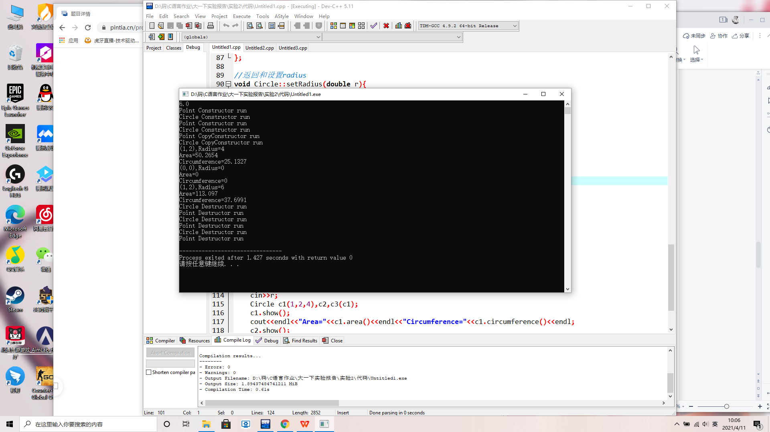
（二）、以人类Person为基类设计学生类Student和教师类Teacher【CPP0014】
【源代码】
此处附上完整的程序源代码，要求包括Person类、Student类、Teacher类和main()，要有必要的注释，不能是图片形式。
#include <iostream>
using namespace std;
//Person类
class Person{
protected:
char no[20]; //身份证号
char name[20]; //姓名
public:
Person(char *str1=0,char *str2=0);//有参构造
Person(const Person &p); //拷贝构造
~Person(); //析构函数
void show() const; //显示Person信息
void setNo(char *str); //设置身份证号
void setName(char *str); //设置姓名
char *getNo(); //获取身份证号
char* getName(); //获取姓名
};
//有参构造
Person::Person(char *str1,char *str2){
int i;
i=0;
if(str1!=0)
while(str1[i]!='\0'){
no[i]=str1[i];
i++;
}
no[i]='\0';
i=0;
if(str2!=0)
while(str2[i]!='\0'){
name[i]=str2[i];
i++;
}
name[i]='\0';
cout<<"Person Constructor run"<<endl;
}
//拷贝构造
Person::Person(const Person &p){
int i=0;
while(p.no[i]!='\0'){
no[i]=p.no[i];
i++;
}
no[i]='\0';
i=0;
while(p.name[i]!='\0'){
name[i]=p.name[i];
i++;
}
name[i]='\0';
cout<<"Person CopyConstructor run"<<endl;
}
//析构函数
Person::~Person(){
cout<<"Person Destructor run"<<endl;
}
//显示Person
void Person::show() const{
cout<<"No="<<no<<",Name="<<name<<endl;
}
//设置身份证号
void Person::setNo(char *str){
int i=0;
if (str)
while(str[i]!='\0'){
no[i]=str[i];
i++;
}
no[i]='\0';
}
//设置姓名
void Person::setName(char *str){
int i=0;
if (str)
while(str[i]!='\0'){
name[i]=str[i];
i++;
}
name[i]='\0';
}
//获取身份证号
char* Person::getNo(){
return no;
}
//获取姓名
char* Person::getName(){
return name;
}

class Teacher:public Person{
char tNo[10];
char departmentName[20];
double wages;
public:
Teacher(char *a=0, char *b=0, char *c=0, char *d=0, double e=0.0):Person(a,b){
int i;
char *p1=getNo();
char *p2=getName();
for(i=0;p1[i]!='\0';i++){
no[i]=p1[i];
}
no[i]='\0';
for(i=0;p2[i]!='\0';i++){
name[i]=p2[i];
}
name[i]='\0';
for(i=0;c[i]!='\0';i++){
tNo[i]=c[i];
}
tNo[i]='\0';
for(i=0;d[i]!='\0';i++){
departmentName[i]=d[i];
}
departmentName[i]='\0';
wages=e;
cout<<"Teacher Constructor run"<<endl;
}
Teacher(const Teacher &f):Person(f){
int i;
for(i=0;f.no[i]!='\0';i++){
no[i]=f.no[i];
}
no[i]='\0';
for(i=0;f.name[i]!='\0';i++){
name[i]=f.name[i];
}
name[i]='\0';
for(i=0;f.tNo[i]!='\0';i++){
tNo[i]=f.tNo[i];
}
tNo[i]='\0';
for(i=0;f.departmentName[i]!='\0';i++){
departmentName[i]=f.departmentName[i];
}
departmentName[i]='\0';
wages=f.wages;
cout<<"Teacher CopyConstructor run"<<endl;
}
~Teacher(){
cout<<"Teacher Destructor run"<<endl;
}
void setTNo(char *);
char * getTNo();
void setDepartmentName(char *);
char* getDepartmentName();
void setWages(double );
double getWages();
void show() const;
};

//分别返回和设置工号tNo
void Teacher::setTNo(char *a='\0'){
int i=0;
while(a[i]!='\0'){
tNo[i]=a[i];
i++;
}
tNo[i]='\0';
}
char *Teacher::getTNo(){
return tNo;
}

//返回和设置部门departmentName
void Teacher::setDepartmentName(char *a='\0'){
int i=0;
while(a[i]!='\0'){
departmentName[i]=a[i];
i++;
}
departmentName[i]='\0';
}
char *Teacher::getDepartmentName(){
return departmentName;
}

//返回和设置工资wages
void Teacher::setWages(double w=0.0){
wages=w;
}
double Teacher::getWages(){
return wages;
}

//显示教师的基本信息
void Teacher::show() const{
int t;
double T;
t=(int)(wages*10);
if((t%10)>4)
T=t/10+1;
else T=t/10;
cout<<"No="<<no<<",Name="<<name<<endl;
cout<<"TNo="<<tNo<<",DepartmentName="<<departmentName<<",Wages="<<T<<endl;
}

class Student:public Person{
char no[20];
char name[20];
char sNo[10];
char className[20];
double score;
public:
Student(char*a=NULL,char *b=NULL,char*c=NULL,char*d=NULL,double t=0):Person(a,b){
char *p1=getNo();
char *p2=getName();
int i;
for(i=0;p1[i]!='\0';i++){
no[i]=p1[i];
}
no[i]='\0';
for(i=0;p2[i]!='\0';i++){
name[i]=p2[i];
}
name[i]='\0';
for(i=0;c[i]!='\0';i++){
sNo[i]=c[i];
}
sNo[i]='\0';
for(i=0;d[i]!='\0';i++){
className[i]=d[i];
}
className[i]='\0';
score=t;
cout<<"Student Constructor run"<<endl;
}
Student(const Student &f):Person(f){
int i=0;
while(f.no[i]!='\0'){
no[i]=f.no[i];
i++;
}
no[i]='\0';
i=0;
while(f.name[i]!='\0'){
name[i]=f.name[i];
i++;
}
name[i]='\0';
i=0;
while(f.sNo[i]!='\0'){
sNo[i]=f.sNo[i];
i++;
}
sNo[i]='\0';
i=0;
while(f.className[i]!='\0'){
className[i]=f.className[i];
i++;
}
className[i]='\0';
score=f.score;
cout<<"Student CopyConstructor run"<<endl;
}
~Student(){
cout<<"Student Destructor run"<<endl;
}
void setSNo(char *);
char * getSNo();
void setClassName(char *);
char* getClassName();
void setScore(double );
double getScore();
void show() const{
cout<<"No="<<no<<",Name="<<name<<endl;
int t,T;
t=(int)(score*10);
if((t%10)>4)
T=t/10+1;
else
T=t/10;
cout<<"SNo="<<sNo<<",ClassName="<<className<<",Score="<<T<<endl;
}
};

//返回和设置学号sNo
void Student::setSNo(char*s )
{
int i=0;
while(s[i]!='\0'){
sNo[i]=s[i];
i++;
}
sNo[i]='\0';
}
char *Student::getSNo(){
return sNo;
}

//返回和设置班级className
void Student::setClassName(char *s){
int i=0;
while(s[i]!='\0'){
className[i]=s[i];
i++;
}
className[i]='\0';
}
char* Student::getClassName(){
return className;
}

//返回和设置成绩score
void Student::setScore(double s=0.0){
score=s;
}
double Student::getScore(){
return score;
}
//主函数
int main(){
char s1[19]="130502190001010332";
char s2[20]="doublebest";
char s3[19]="20181234";
char s4[20]="铁1801";
double value=60.67;
Student stu1(s1,s2,s3,s4,value);
stu1.show();
Student stu2=stu1;
cin.getline(s3,10,'\n');
cin.getline(s4,20,'\n');
cin>>value;
stu2.setSNo(s3);
stu2.setClassName(s4);
stu2.show();
Teacher t1(s1,s2,s3,s4,value);
t1.show();
Teacher t2=t1;
t2.setTNo(s3);
t2.setDepartmentName(s3);
t2.show();
return 0;
}
【运行测试】
此处附上程序运行的测试截图
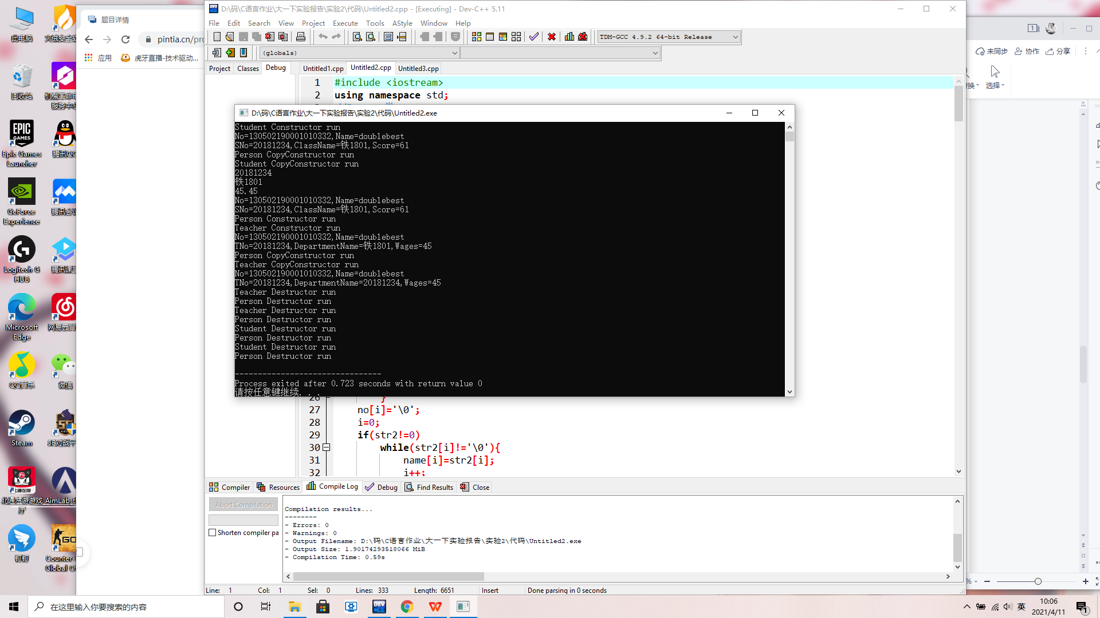
（三）、以圆类Circle为基础设计球类Sphere【CPP0015】
【源代码】
此处附上完整的程序源代码，要求包括Point类、Circle类、Sphere类和main()，要有必要的注释，不能是图片形式。
#include <iostream>
using namespace std;
//Point类
class Point{
protected:
double x;
double y;
public:
Point(double xv=0,double yv=0);//有参构造
Point(const Point &p); //拷贝构造
~Point(); //析构函数
void show() const; //显示Point信息
double area()const; //面积=0
void setX(double xv); //设置X坐标
void setY(double yv); //设置Y坐标
double getX() const; //获取X坐标
double getY() const; //获取Y坐标
};
//有参构造
Point::Point(double xv,double yv){
x=xv;
y=yv;
cout<<"Point Constructor run"<<endl;
}
//拷贝构造
Point::Point(const Point &p){
x=p.x;
y=p.y;
cout<<"Point CopyConstructor run"<<endl;
}
//析构函数
Point::~Point(){
cout<<"Point Destructor run"<<endl;
}
//显示Point
void Point::show() const{
cout<<"("<<x<<","<<y<<")";
}
//设置X坐标
void Point::setX(double xv){
x=xv;
}
//设置Y坐标
void Point::setY(double yv){
y=yv;
}
//面积函数
double Point::area() const{
return 0;
}
//获取X坐标
double Point::getX() const{
return x;
}
//获取Y坐标
double Point::getY() const{
return y;
}

const double PI=3.14159;

class Circle:public Point{
double radius;
public:
Circle(double x=0,double y=0,double r=0):Point(x,y){
this->radius=r;
cout<<"Circle Constructor run"<<endl;
}
Circle(Circle &a):Point(a){
//x=a.x;
//y=a.y;
radius=a.radius;
cout<<"Circle CopyConstructor run"<<endl;
}
~Circle(){
cout<<"Circle Destructor run"<<endl;
}
void setRadius(double r=0){
radius=r;
}
double getRadius() const{
return radius;
}
double circumference() const{
return 2*PI*radius;
}
double area() const{
return PI*radius*radius;
}
void show() const{
cout<<"("<<x<<","<<y<<"),Radius="<<radius;
}
};

class Sphere:public Circle{
public:
Sphere(double x=0,double y=0,double r=0):Circle(x,y,r){
//x=Point::getX();
//y=Point::getY();
//this->radius=r;
cout<<"Sphere Constructor run"<<endl;
}
Sphere(Sphere &a):Circle(a){
//x=a.x;
//y=a.y;
//radius=a.radius;
cout<<"Sphere CopyConstructor run"<<endl;
}
~Sphere(){
cout<<"Sphere Destructor run"<<endl;
}
double volume() const{
double r=Circle::getRadius();
return 4*PI*r*r*r/3;
}
double area() const{
double r=Circle::getRadius();
return 4*PI*r*r;
}
};
//主函数
int main(void){
double r;
cin>>r;
Sphere s1(1,2,4),s2(s1);
s1.show();
cout<<endl<<"Area="<<s1.area()<<endl<<"Volume="<<s1.volume()<<endl;
s2.setRadius(r);
s2.Circle::show();
cout<<endl<<"Area="<<s2.Circle::area()<<endl<<"Circumference="<<s2.Circle::circumference()<<endl;
return 0;
}
【运行测试】
此处附上程序运行的测试截图
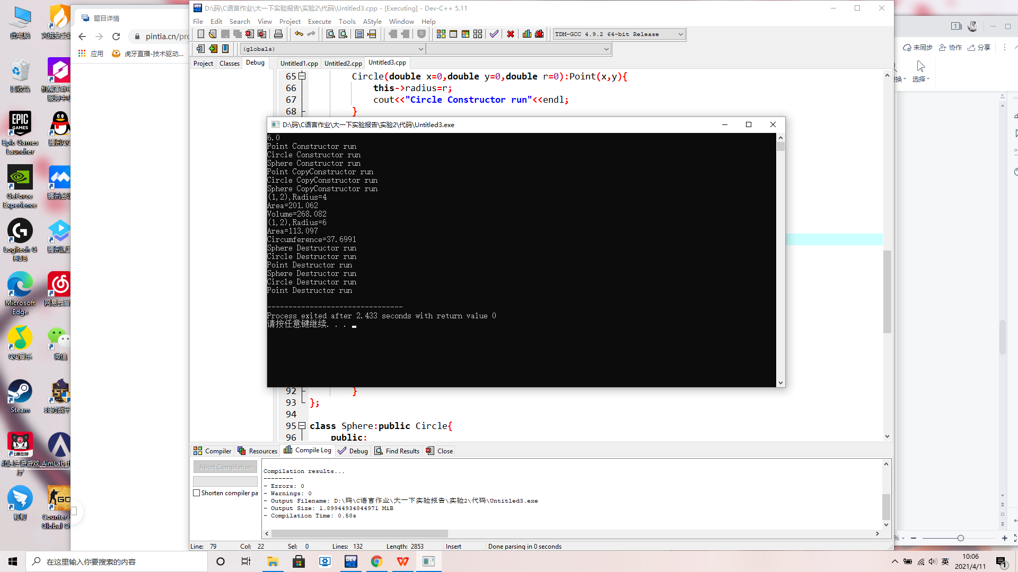
四 实验分析及问题思考
1、查阅资料，结合程序实例，分析总结若基类中的数据成员 的访问权限为private，对于类的继承实现有无影响？【CPP0016】
【答案】此处附上问题答案
代码：class Circle:public Point{
double radius;
public:
Circle(double x=0,double y=0,double r=0):Point(x,y){
this->radius=r;
cout<<"Circle Constructor run"<<endl;
}
Circle(Circle &a):Point(a){
//x=a.x;
//y=a.y;
radius=a.radius;
cout<<"Circle CopyConstructor run"<<endl;
}
~Circle(){
cout<<"Circle Destructor run"<<endl;
}
void setRadius(double r=0){
radius=r;6
}
double getRadius() const{
return radius;
}
double circumference() const{
return 2*PI*radius;
}
double area() const{
return PI*radius*radius;
}
void show() const{
cout<<"("<<x<<","<<y<<"),Radius="<<radius;
}
};

class Sphere:public Circle{
public:
Sphere(double x=0,double y=0,double r=0):Circle(x,y,r){
//x=Point::getX();
//y=Point::getY();
//this->radius=r;
cout<<"Sphere Constructor run"<<endl;
}
Sphere(Sphere &a):Circle(a){
//x=a.x;
//y=a.y;
//radius=a.radius;
cout<<"Sphere CopyConstructor run"<<endl;
}
~Sphere(){
cout<<"Sphere Destructor run"<<endl;
}
double volume() const{
double r=Circle::getRadius();
return 4*PI*r*r*r/3;
}
double area() const{
double r=Circle::getRadius();
return 4*PI*r*r;
}
};
其中Circle类中的radius为私有成员，Sphere继承Circle，但是仍然无法使用radius，只能通过基类的公有函数获得radius的值

2、查阅资料，结合程序实例，分析总结类族中不同继承模式下成员访问权限；【CPP0017】
【答案】此处附上问题答案

代码：#include<iostream>
using namespace std;
//基类People
class People{
public:
void setname(char *name);
void setage(int age);
void sethobby(char *hobby);
char *gethobby();
protected:
char *m_name;
int m_age;
private:
char *m_hobby;
};
void People::setname(char *name){ m_name = name; }
void People::setage(int age){ m_age = age; }
void People::sethobby(char *hobby){ m_hobby = hobby; }
char *People::gethobby(){ return m_hobby; }
//派生类Student
class Student: public People{
public:
void setscore(float score);
protected:
float m_score;
};
void Student::setscore(float score){ m_score = score; }
//派生类Pupil
class Pupil: public Student{
public:
void setranking(int ranking);
void display();
private:
int m_ranking;
};
void Pupil::setranking(int ranking){ m_ranking = ranking; }
void Pupil::display(){
cout<<m_name<<"的年龄是"<<m_age<<"，考试成绩为"<<m_score<<"分，班级排名第"<<m_ranking<<"，TA喜欢"<<gethobby()<<"。"<<endl;
}
int main(){
Pupil pup;
pup.setname("小明");
pup.setage(15);
pup.setscore(92.5f);
pup.setranking(4);
pup.sethobby("乒乓球");
pup.display();
return 0;
}
c++不管哪种继承方式，基类的私有数据成员都是不可见的；public继承，派生类可以直接访问基类的publi成员，以派生类的方式访问protected成员；protected继承时，对基类的public和protected成员均为保护成员形式访问；
private继承时，public、protected、private均视为私有数据成员不可访问
C++类的继承与派生(10003809171j)
班级:信2007-2 学号:20203907 姓名:周朝勇
实验自评
实验内容 | 自评结果（在对应格内打✓）
实验内容 | 熟练 | 比较熟练 | 一般 | 不熟练
派生类的定义【CPP0018】 |  | ✓
继承模式【CPP0019】 |  | ✓
派生类成员访问权限【CPP0020】 |  | ✓
派生类构造函数【CPP0021】 |  | ✓
派生类析构函数【CPP0022】 |  | ✓
实验体会
更清楚了解到基类和派生类的关系，以及成员访问间的联系与方式

